- Explain p-type and n-type semiconductor with example.
- Rationalize the bond lengths of CO (1.128Å) and CO⁺ (1.115Å) with the help of MO diagram. Explain the ligating behaviour of CO.
The bond lengths can be rationalized with the help of bond order. The MO electronic configuration of CO is 1σ², 2σ²,(1πx²=1πy²), 3σ², (2πx⁰=2πy⁰), 4σ⁰. Bond order of CO is thus (8-2)/2 = 3
considering the electronic configuration of : In the case of CO+, the increased effective nuclear charge on oxygen, the energy of 2p atomic orbital of oxygen becomes much lower in energy, due to which the energy of 1πpx, 1πpy and 3σ BMOs becomes lower than the energy of 2σ antibonding MO of CO. The MO electronic configuration of CO is 1σ², (1πx²=1πy²), 3σ², 2σ¹, (2πx⁰=2πy⁰), 4σ⁰. Hence bond order of CO+ is (8-1)/2 = 3.5
Since bond order of CO is less than CO+ thus it has a longer bond length than CO+.
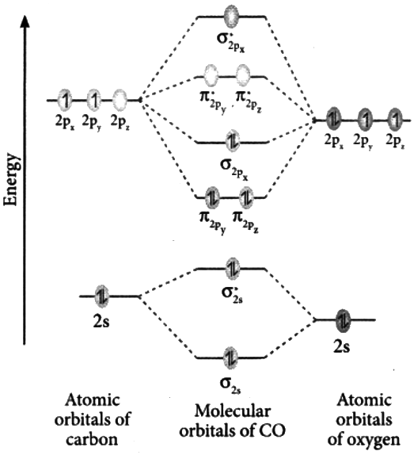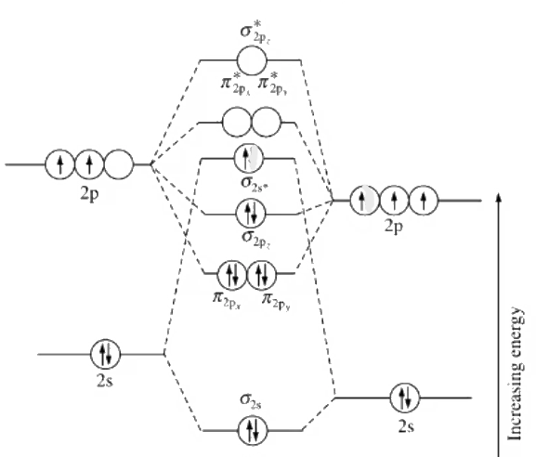
MO of CO+

- Assuming X-axis as the bonding axis, predict how many π-MO’s would be formed by d-orbitals of two combining atoms. Give the overlap diagram in each case.
Since X-axis is the bonding axis the two atoms will approach with their d orbitals along the x-axis. So there will be direct overlap of the d_{x}2─_{y}2 that will produce σ MOs. In case of d_{xy}, and d_{xz}, orbitals, two out of four lobes (one +ve and one -ve) from each will overlap partially to give 2 π bonding and 2π anti-bonding molecular orbitals whereas the d_{yz} orbitals will overlap partially to form delta bond. The d_{z}2 orbital here will not form any MO as it cannot come close enough to make an effective overlap.
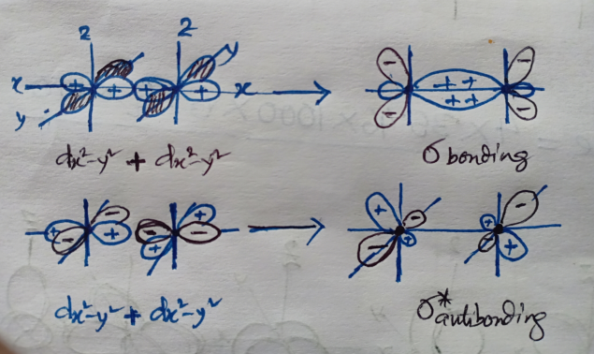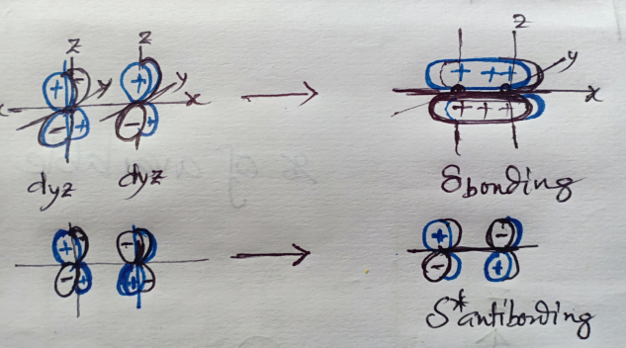
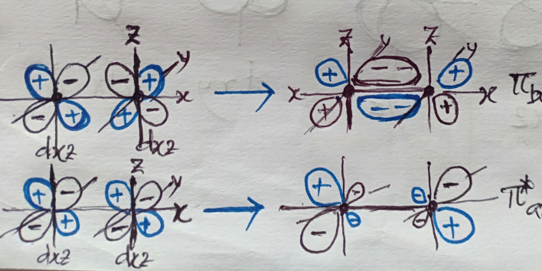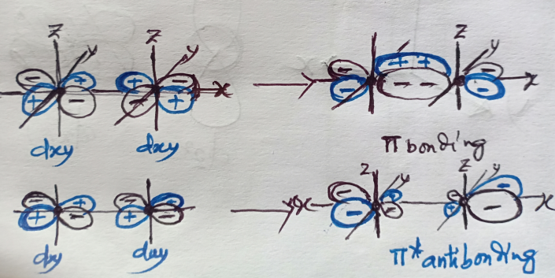

- Justify the following bond energy and bond length data from MO theory with diagram.
NO NO⁺ NO─
Bond energy (kJ mol^{─1}) 627 1047 488
Bond length (Å) 1.15 1.06 1.26

- What is intrinsic and extrinsic semiconductor?
- Construct MO energy level diagram of HF molecule and discuss on which atom bonding and antibonding electrons are located?
- Discuss Frenkel and Schottky defects. Discuss the kind of crystal defect observed when ZnO is heated. State the detectable change.
- MgSO₄ is freely soluble in water where as BaSO4 is almost insoluble. On the other hand MnO is 2000 times more soluble then MgO in water.
- Explain ion-dipole, dipole-dipole, and dipole-induced dipole interactions mentioning one example in each case.
- The thermal stability of isomorphus sulphates of Ca, Sr, and Ba with respect to decomposition into the metal oxide MO and SO₄ increases in the sequence CuSO₄< SrSO₄<BaSO₄ – explain.
- Construct the MO diagram of Li₂, Li₃, and Li_{n} molecules and analyze the related properties.
- Construct the MO diagram of H₂O molecule and calculate its bond order.
- Compare electronic configuration, paramagnetic and ligational behaviour of CO, and NO molecule.
In CO there is a lone pair of electrons in 3σ( or σ_{2pz}) orbital that can be used for σ donation to a vacant acceptor orbital of metal to form a coordinate bond. Again it can use its vacant 2π (or π*_{2px} and π*_{2py}) LUMOs to accept electrons from filled metal orbitals to form π bonds (back bonding). NO also can use its 3σ electron pair to form coordination bond with metal and vacant π* antibonding orbitals for accepting π electrons to form π back bond. Thus both can act as good ligands to form coordination compounds.
However the ligating strength of CO is greater than that of NO. This is due to two reasons. In CO the 3σ MO is located closer to the C atom but in NO it is closer to the O atom. Lower electro negativity of C makes donation of the 3σ electrons easier. Again presence of an unpaired electron in the 2π MO of NO causes repulsion during accepting electrons from filled metal orbitals to form π back bonds. As a result CO act as a better ligand than NO.

- Solubility trends of fluorides of alkali metals in water are CsF>RbF>NaF>LiF. But this trend is reverse for iodides.
Polarizing power of cation increases with decrease of size. Again with increasing polarizing power of cation the compound becomes more covalent. On going down a group the size of the cation increases and hence polarizing power decreases. Due to smallest size of Li+ it is most polarizing. Thus LiF is most covalent or least ionic where as CsF is least covalent or most ionic. Hence the trend.
- With rough energy level diagram, show the ground state electron configuration of (a) H₂─, (b)N₂, (c) B₂─. Find the bond order in each case.
- Give ground state MO electronic configuration of ClF, CO, and CS.
- Which of the molecules are expected to be stabilized by (a) addition of electron, (b) removal of electron? (a) NO, (b) C₂, (c) O₂, (d) CN. Answer by qualitative MO description.
- Describe in which of the following combinations of the AOs will result in fruitful overlap and formation of MO (consider z axis as the internuclear axis). (a) (3d_{z2} +3d_{yz}), (b) (3d_{yz} + 3d_{xz}), (c) (2s + 3d_{x2 – y2})
- Show the formation of σ, π, and δ bonds by overlap of appropriate d-orbitals of two identical d-bloc atoms (z-axis as the internuclear axis).
- The energy required to dissociate one O atom from different dioxygen species are reported as (in kJ mol^{─1}): 623, 494, 351, and 205. Correlate these terms with the species O₂^{2─}, O₂─, O₂, and O₂⁺. Explain.
- HF forms stronger H-bonds than H₂O. Still ΔH_{vap} of HF is lower than that of H₂O. – Explain.
- Electron affinity of C₂ (341 kJmol^{─1}) is much greater than that of N₂ ( ─212 kjmol^{─1}) or O₂ (42 kjmol^{─1}) – Explain.
Hint: Write MO electronic configuration or draw MO diagram of C₂, N₂, and O₂. If added electron enters in bonding MO then the molecule has higher electron affinity, but if the electron enters in antibonding MO then the molecule will have low electron affinity.
- How and under what condition an insulator can be converted to semiconductor?
An insulator can be converted into a semiconductor through a process called doping. Doping involves introducing impurities into the crystal lattice of the insulator. This can be achieved by adding specific atoms, such as phosphorus or boron, to the insulator material. When these impurity atoms are added, they can either donate extra electrons (n-type doping) or create "holes" where electrons can move (p-type doping), thus altering the conductivity of the material. By carefully controlling the type and amount of dopants, the insulator can be converted into a semiconductor with specific electrical properties.
- Draw the MO of HF and HCL and find HOMO, LUMO and the number of non-bonding electrons.
- CO and N₂ are iso-electronic but they differ greatly in donar properties. – Explain.
This is due to nonpolar character of N₂. Since the participating AOs originate from identical atoms, the resulting MO energy energy levels do not offer the advantage of σ donation and π acceptance to any significant extent. The LUMO in CO is largely responsible for good π acceptor property─ its low energy and high amplitude on its carbon donor atom allows good overlap with the metal d orbitals. The symmetrical N₂ molecule is clearly devoid of this advantage.

- Explain why liquid oxygen sticks to magnetic pot.
MO electronic configuration of oxygen shows presence of unpaired electrons in its 2π antibonding MOs. This make O₂ to be paramagnetic and so O₂ in the liquid form gets attracted to magnetic poles.
- Indicate the type of semiconductor (n-type or p-type) expected to form in the following, (i) As doped Ge, (ii) B doped Si.
- State the change of bond orders with reasons in the following ionization processes; (i) O₂ → O₂⁺ + e, (ii) NO⁺ + e → NO.
- Which one has a higher bond order, N₂ or NO?
- What is the magnetic character of the anion of KO₂?
- Why N₂⁺ has a longer bond length than N₂ but O₂⁺ has a smaller bond length than O₂.

